AUM Amriteswaryai Namah

Assignment 2 on Mininet

Deliverable

1. Screenshot for Pingall before and after adding flow table entries.
2. Screenshot for dump-flow commands
3. Run this command to create a simple host with 3 hosts and 1 Open vswitch and a remote controller sudo mn --topo single,3 --mac --switch ovsk --controller remote

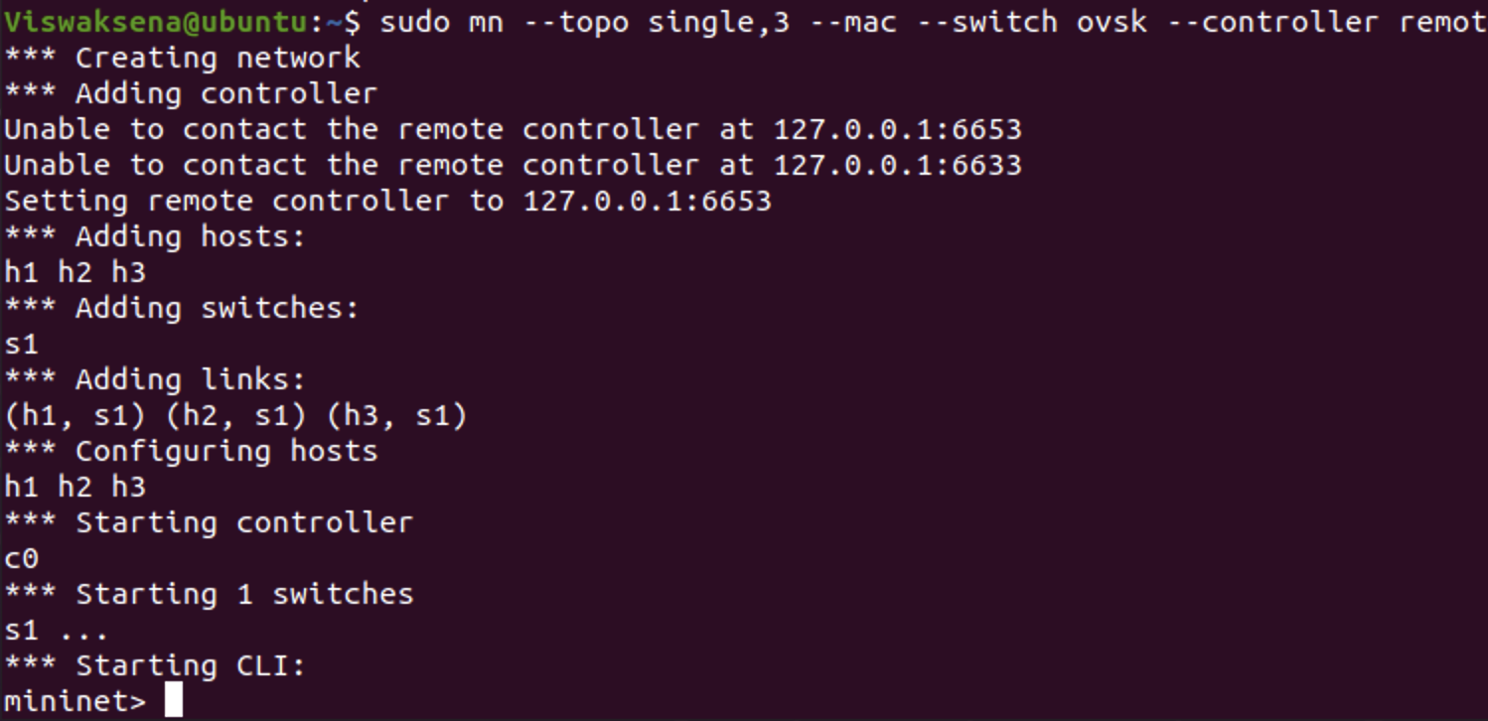

1. Run a net command and see all the interfaces and find out how the switches are connected to each other.

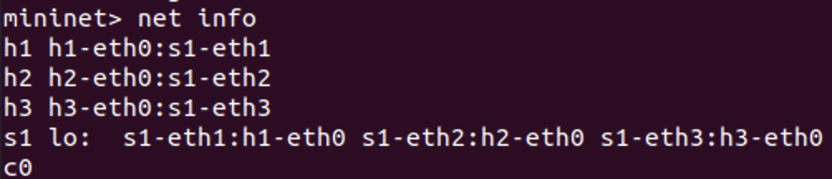

1. Run a pingall command on mininet prompt and write the output. Explain the reason why you got the output that way.

Due to absence of entries in flow table, packets are struct which host it need to reach. So for this reason 100% packet loss get occurs. To receive packets we need to give inputs to the flow table then they can do conversation.

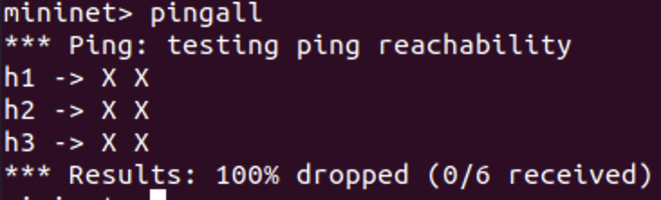

1. Next, you see the flow table at the switch s1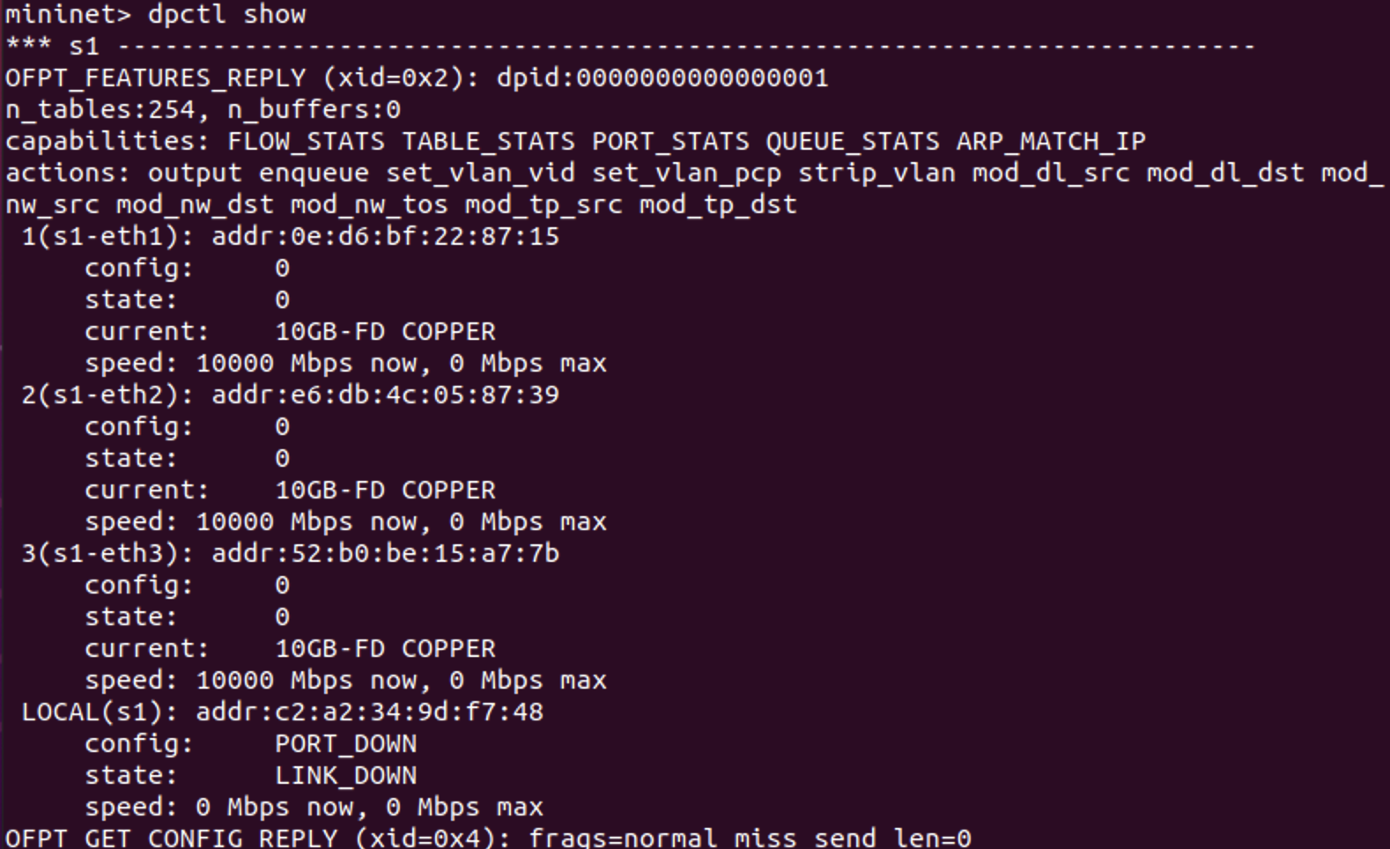
2. $ovs-ofctl add-flow tcp:127.0.0.1:6654 in_port=1,idle_timeout=1000,actions=output:2



1. $ovs-ofctl add-flow tcp:127.0.0.1:6654 in_port=2,idle_timeout=1000,actions=output:1



1. $ovs-ofctl dump-flows tcp:127.0.0.1:6654

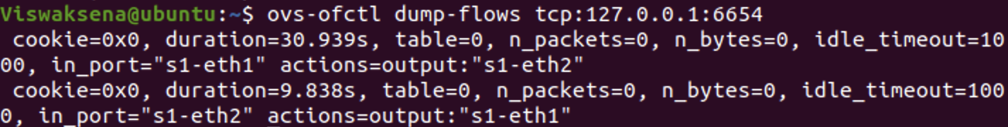

1. Mininet> pingall

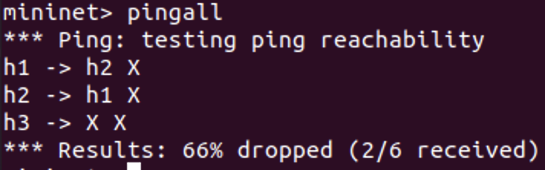

1. **h1 and h2 are now connected. [ If there are switches, Port 6655 is used for Switch S2]**

From the below diagram we can say that the host 1 and host 2 are connected transmitted packets from h1 to h2, we get 0% packet loss, same from h2 to h1. But from h3 to h2,h1 transmitted 21 packets then happens 100% packet loss. h3 to h1 either h2 are not connected. Because we only given entries to flow table only for h1 and h2 only.

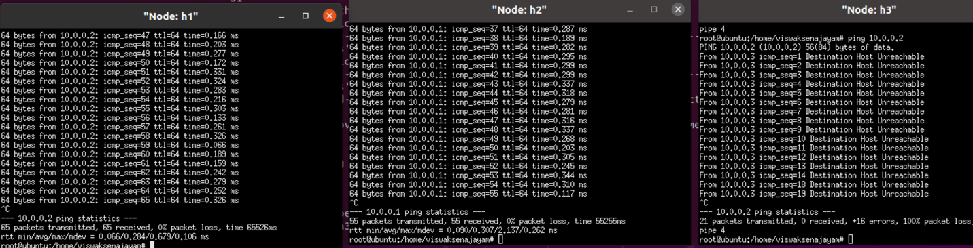

1. Start Wireshark on a window and before doing the next dump-flows command, start capturing packets.
2. $ovs-ofctl dump-flows tcp:127.0.0.1:6654 and check the statistics on packet sent

